**Keywords in python**

**1.and:**The and keyword is a **logical operator** used to combine conditional statements. It returns True if both conditions are True; otherwise, it returns False.

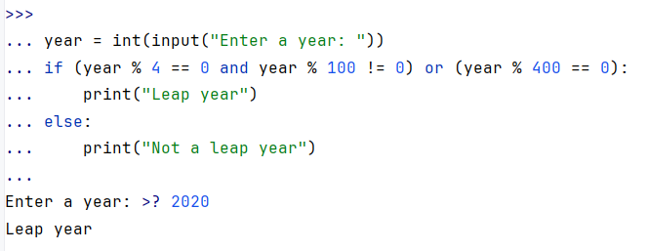

2.or:The or keyword is another **logical operator** that returns True if at least one of the conditions is True.

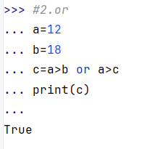

**3.not:**The not keyword is a **logical operator** that negates (reverses) a condition. If the condition is True, not makes it False and vice versa.

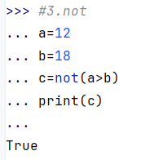

**4.if:**The if keyword is used to start a conditional statement. If the condition evaluates to True, the block of code under if will execute.

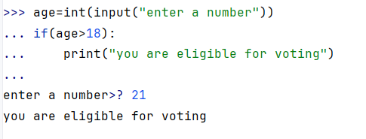

**5.else:**The else keyword is used to define a block of code that runs if the if condition is False.

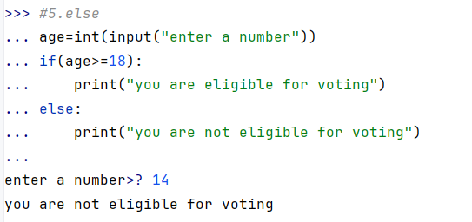

**6.elif:**The elif (short for **else if**) keyword is used to check multiple conditions. It is placed after if and before else.

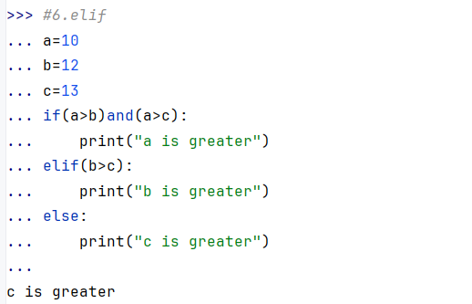

**7.while:**The while keyword is used to create a **loop** that executes as long as the condition is True.

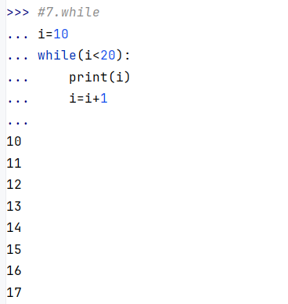

**8.for:**The for keyword is used for looping through a sequence (like a list, tuple, dictionary, or range).

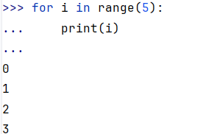

**9.in:**The in keyword is used to check if a value exists in a sequence (list, tuple, etc.) or to iterate through a sequence in a for loop.

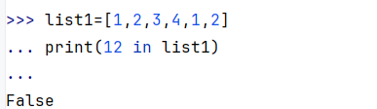

1. **Non local:**Used inside nested functions to refer to a variable in the nearest enclosing scope (excluding global scope). It allows you to modify a variable from an outer, non-global scope.

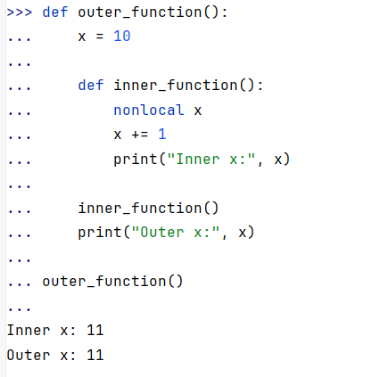

1. **Global:**Declares a variable as global, meaning it is accessible and modifiable outside its local scope.

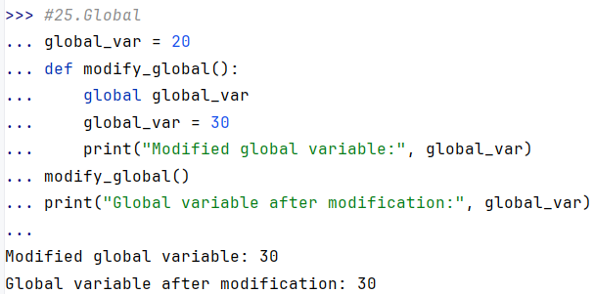

1. **With:**Used to simplify the management of resources, such as file handling. It ensures proper acquisition and release of resources.

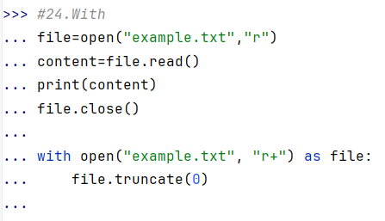

**Lambda:**Defines an anonymous function in a single line. Often used for short functions without a name.

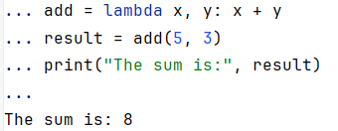

**Is:**Compares two objects to check if they are the same object (identity comparison).

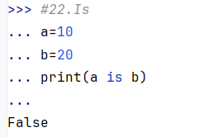

**None:**Represents the absence of a value or a null value in Python.

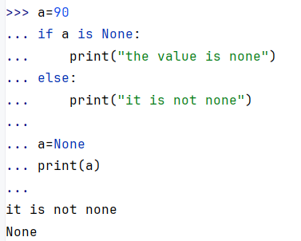

**False:**A Boolean constant representing the logical value False.

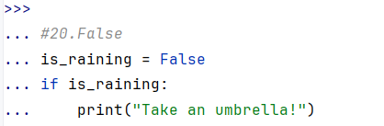

**True:**A Boolean constant representing the logical value True.

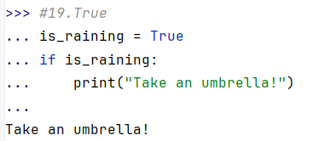

**From:**Used in import statements to import specific parts of a module.

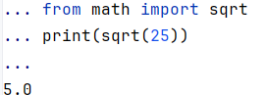

**As:**Used to give an alias to a module or object during import.

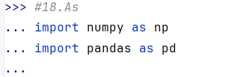

**Import:**Used to import modules or specific objects from modules.

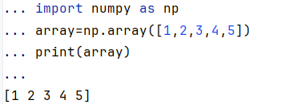

**Class:**Used to define a class, which is a blueprint for creating objects.

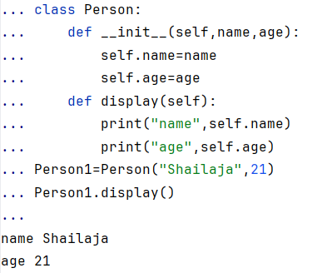

**Def:**Used to define a function.

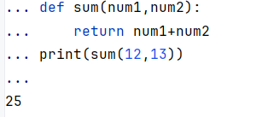

**Return:**Exits a function and optionally returns a value.

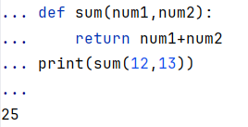

**Finally:**Used in exception handling. The block inside finally always executes, regardless of whether an exception occurs.

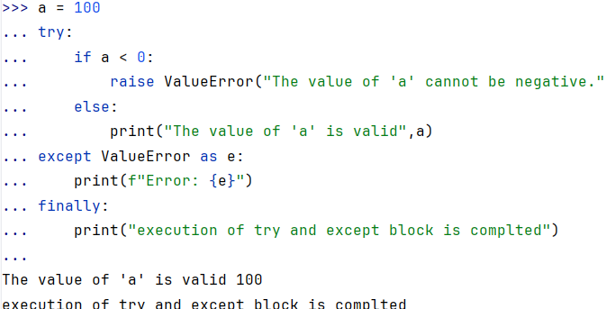

**Except:**Specifies the block of code to handle an exception.

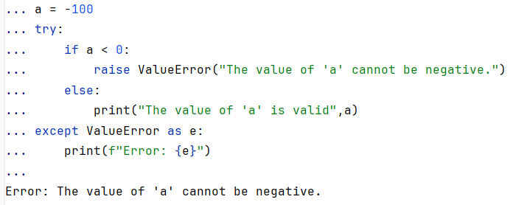

**Try:**Defines a block of code to test for exceptions.

